

2022 – 12 ATAR Psychology

Task One - Topic Test
5%

Biological Influences and
Bases of Behaviour

Name:
Time: 45 minutes
Score: /46

The diagram below shows the structure of a motor neuron.
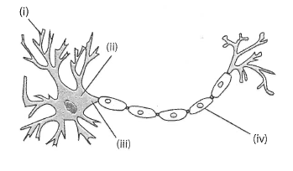

Structure of a motor neuron

- Describe the purpose of the structure labelled at (i) in the diagram. (1 mark)

- Identify the division of the nervous system in which a motor neuron would be found.
(1 mark)

- Name TWO neurotransmitters that are secreted in the brain. (2 marks)

- Briefly describe how neurotransmitters are transferred from one neuron to another. You may use an annotated diagram to answer this question. (4 marks)

- Referring to the diagram below, name parts A and B, and briefly explain how they work together to enable a person to respond to a bicycle bell being sounded while they are walking in the middle of a pathway. (5 marks)

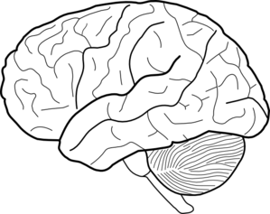
A
B

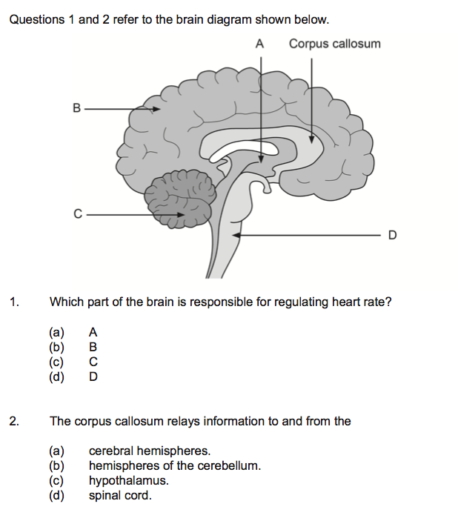
- Refer to the following diagram to answer the following questions.

- Describe the structure of the corpus callosum and state its function. (2 marks)

- Name the area of the brainstem labelled “D”. State two functions of D. (3 marks)

- Name the structure that would be found at “A”. (1 mark)

- Use an arrow to indicate where the frontal lobe exists. (1 mark)

- State two functions of the frontal lobe of the brain. (2 marks)

- Refer to the following diagram to answer the following questions. The diagram below shows a section of spinal cord.
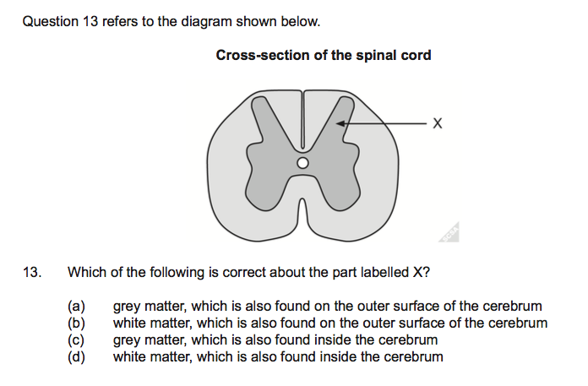

- Identify the structural material that “X” is pointing to. (1 mark)

- Name the main part of the brain where “X” would be found. (1 mark)

- State two functions of the spinal cord. (2 marks)

- The ‘flight or fight’ response happens when people are confronted with something that could potentially be dangerous.

- Give one real-life example of a situation where the flight or fight response would occur. (1 mark)

- Name one neurotransmitter responsible for this response. (1 mark)

- Provide two examples of changes to the way the human body functions as a response to fight or flight. (2 marks)

a) If the occipital lobe of the brain was damaged, explain the possible effects a person may experience. (2 marks)

b) If Wernicke’s area is damaged, explain the possible effects a person may experience.
(2 marks)

- Using your knowledge and understanding of genetics, describe three examples of the effects of genetic factors on behaviour. (3 marks)

- Complete this table on psychoactive drugs: (9 marks)
Class of drug | One (1) physiological effect | One (1) psychological effect | Example of a drug in this class
Depressant
Stimulant
Hallucinogen

END OF TEST

